Cumulative Defects by Status
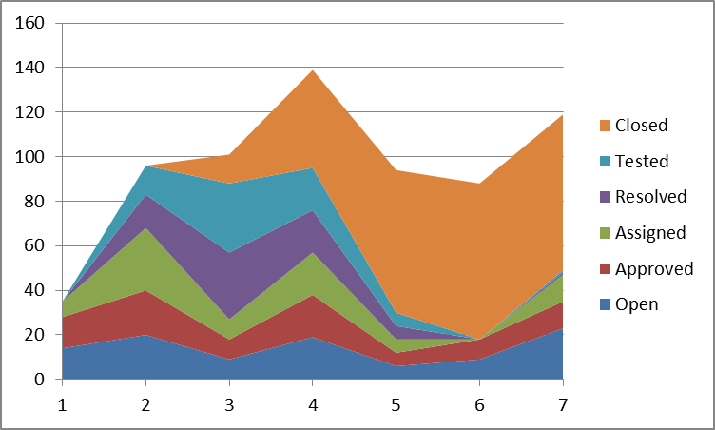
Cumulative Defects by Status

Assumption from chart:
- Defect collection was performed before beginning time in Viking_Product_Defect_Data.xls file.
- There was defects had been opened before was closed in Viking_Product_Defect_Data.xls file.
- The beginning time of Viking_Product_Defect_Data.xls file will be assume at the start time of testing phase.
- The testing phase lasted for 15 weeks, so the data only show the status of defects at half way of testing phase.
Comment: The project team worked quite well, there have defects has been opened before starting the testing phase , for 7 weeks testing team worked and has 261 defect closed, the defects arising until the seventh week is 100. So the project team has a fix and close defects from the previous stage with good performance.

